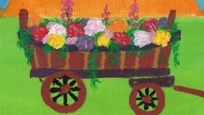

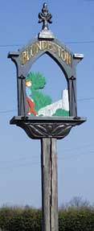
Blundeston in Bloom

Index

Page 2 Introduction

Page 5 Names and Roles of our Team

Page 6 Information about our Community

Page 6 Section 1: Horticultural Achievement

Page 11 Section 2: Environmental Responsibility

Page 11 1. The Millennium Green

Page 12 2. Barkis Meadow

Page 13 3. Roadside verges

Page 13 4. Recycling Materials

Page 14 Section 3: Community Involvement

Page 14 1. St Mary’s Church

Page 14 2. The Millennium Green

Page 15 3. The Bowls Club

Page 16 4. Blundeston School

Page 16 5. The Plough Inn

Page 17 6. Fundraising

Introduction
The commitment to get Blundeston and its inhabitants involved in the ‘Blundeston in Bloom’ initiative was first made in the autumn of 2010. This is the first year – 2012, that we have invited the judges from Anglia in Bloom to come and visit the village. We look forward to showing them the progress that we have made in a relatively short time and to listening to their advice on the way forward in the future.

Over the period since we started we have set up a formal committee and have held regular open meetings to progress the project through its first year. Support has been steady over that period with a hard core of about fifteen actively involved, through the meetings, but with support from many other villagers. We have been grateful over that period for help and advice from our neighbours involved in the Oulton Broad in Bloom project.Through this project the committee want to inspire and motivate people to take more responsibility for their environment and to try to put the local community in control thus making it easier for individuals to act positively. Our small band of instigators is realistic enough to know that this may be a slow process and that we will have to be patient and make haste slowly.

The Village is fortunate in having a number of interesting focal points with a now well established Millennium Green at its centre. This is the site of numerous communal activities, most recently the celebrations of the Queen’s diamond jubilee. Within sight of the Green we have the Church with its Saxon Tower and the old Rectory, both featured in Charles Dickens classic novel, David Copperfield. Also the Cattle Pound, the Village sign, the Village Hall and the remains of the Windmill. The round structure of some of these historical buildings is reflected in the round stand of ten native oak trees surrounding the beacon on the Millennium Green.

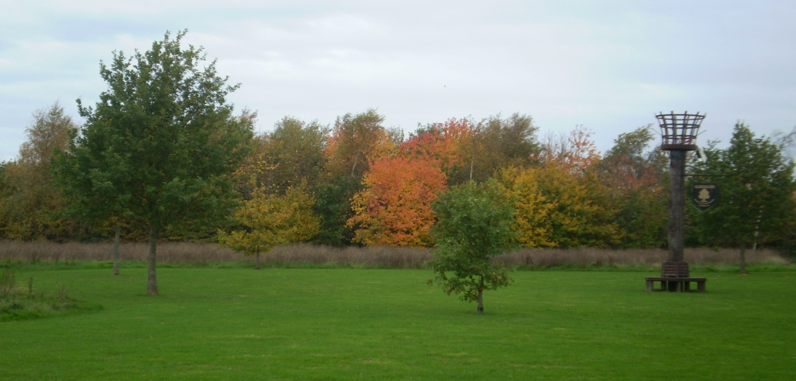

The Millennium Green in its autumn glory. The jewel in the village crown (Oct. 2010)
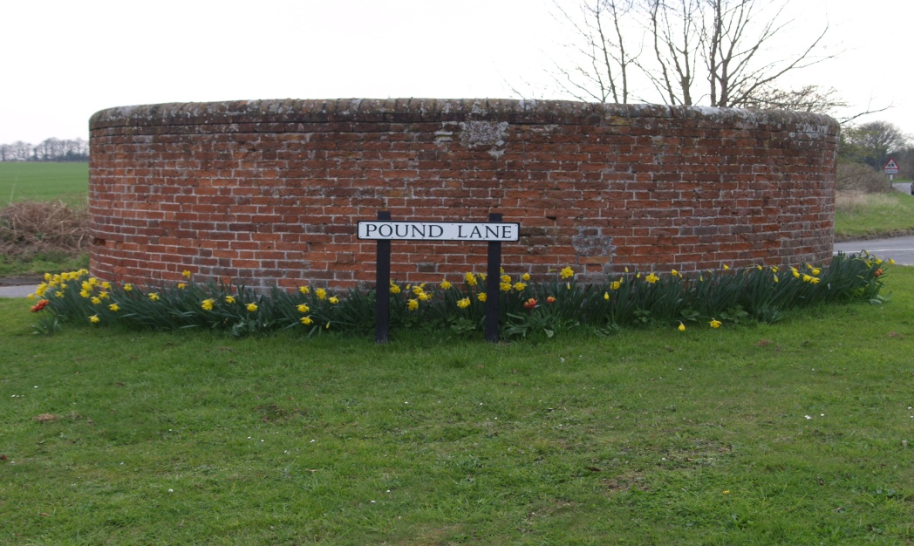

The old cattle pound (April 2012)

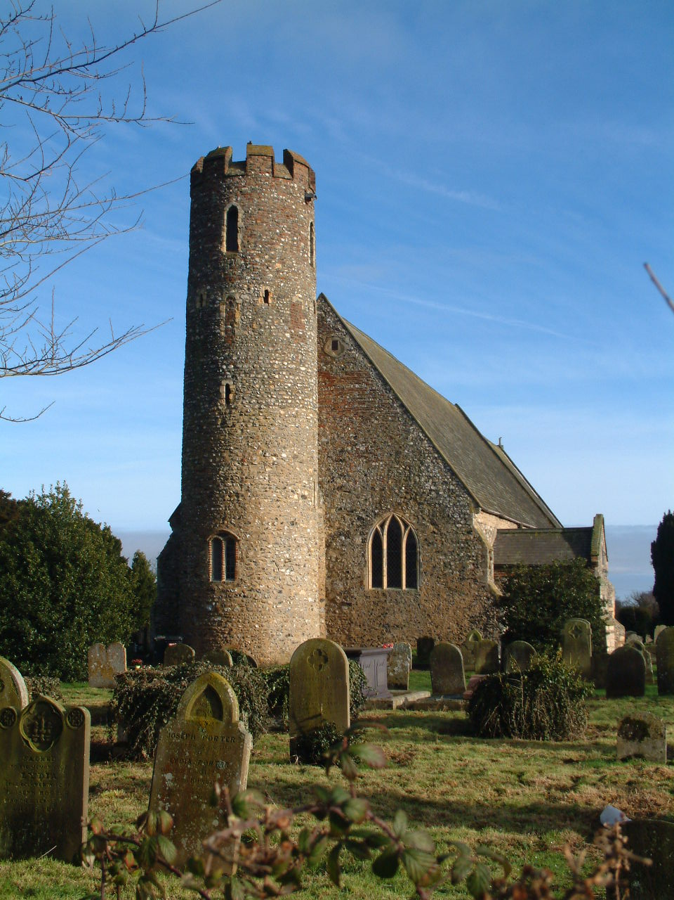

St Mary’s Church with its round Saxon tower (Jan. 2011)

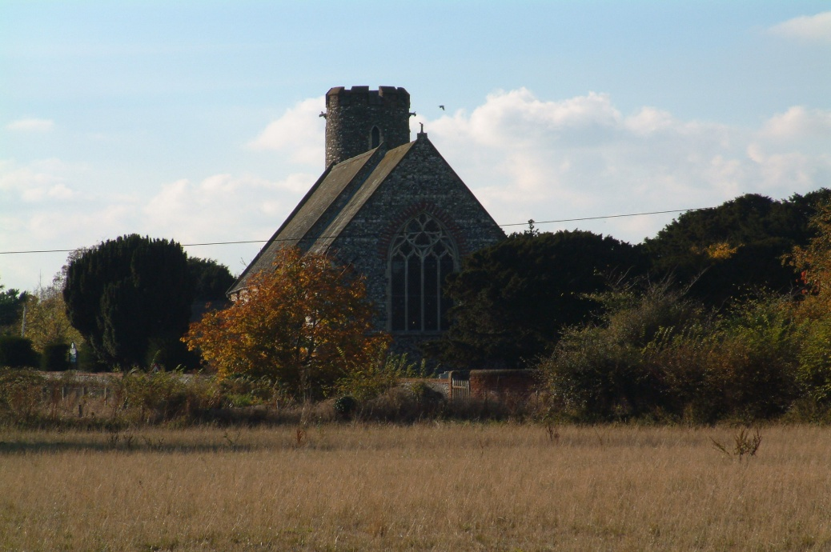

The Church and Pound as David Copperfield would have seen it

Names and roles of our team
Chair: Graham Wade
Graham has been the main driving force behind this project. He is a professional horticulturalist and a very practical person. In everything that has been done so far he has led from the front.

Secretary: Alison Shelton
Alison very ably assisits Graham as Secretary and also in a very hands on pracrtical sense with making things clearing and planting out. She is also an accomplished photographer and has supplied some of the photographs for this document.

Treasurer: John Nichols
John is more at home with his computer and paperwork than with practical gardening. He very quickly volunteered to look after the finances and the Portfolio and also competes with Alison on the photographic side.

Members: Geraldine Bailey, Ron and Carol Larcombe, Angela Nichols, Barbara Shaw, Angela Teasdale, Susan Wade, Ken Ward, Peter Spandler, Rob and Sam Gooch.
These individuals all bring whatever time and talents they have available and have worked very hard to achieve the progress so far.

Working in partnership: Blundestion Primary School
Blundeston and Flixton Parish Council.
Millennium Green Trustees
NOMS Community Payback Scheme
SOLD were commissioned to make our logo themed hay cart.
St Mary’s Church PCC
Waveney Norse – grass cutting areas liaison re. planters

Sponsorship: ASCO (UK)
Badger Builders
Barbara Shaw
Blundeston WI
Helen Brown
HM Prison Blundeston
Jackie Schader
Lound Plant Centre
Mark @ Signs
Paul Taverner
Pauline Reid
Somerleyton Post Office
PR Offshore Services
Suffolk County Council (Locality budget)
Suffolk Wildlife Trust
The Larcombe Family
The Plough Inn
Witham Paints and Oils (Lowestoft Ltd)
Worx Hopton

Information about our Community
A map of our Village showing the main landmarks. The site of the old Methodist Church now has two detached houses on it and the Red Lion is now closed as a public House with the owners seeking to demolish it and put four dwellings on the site. The Parish have had an influential and important input to this proposed development with the original plans being turned down on appeal as not being in keeping with the street scene. Revised plans for three lower level dwellings have now been agreed.

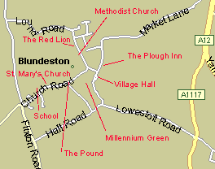

The Village Community is a very active one with those activities centred around both the Church and the Village Hall. There are numerous organisations which meet regularly in the Village Hall which is in almost constant daily use.
The Parish Council meets monthly and is well attended by parishioners.
The Village has a Charity trustees board which meets regularly and manages land, property and investments held by the Trust. They are able to use their profits for the benefit of the poor and needy of the Parish.
The Millennium Green was originally set up under a nationawide initiative of the Countryside Commission (now Natural England) in 1999, to create 2000 new village and urban Greens. Blundeston Green was the first to be funded and established in Suffolk and is on Glebe land formerly owned by the Church Commissioners.The original board of trustees is now in the legal process of handing over control and responsibility to the Parish Council in line with advice and guidance from Natural England.

Section 1: Horticultural Achievement

The first goal for this project was to tidy up and to brighten up our village using Blundeston in Bloom as the vehicle through which to achieve our aim. We started in the autumn of 2010 targeting a few strategic areas around the village. These areas were planted with spring flowering bulbs and had planters with summer flowers placed in them.
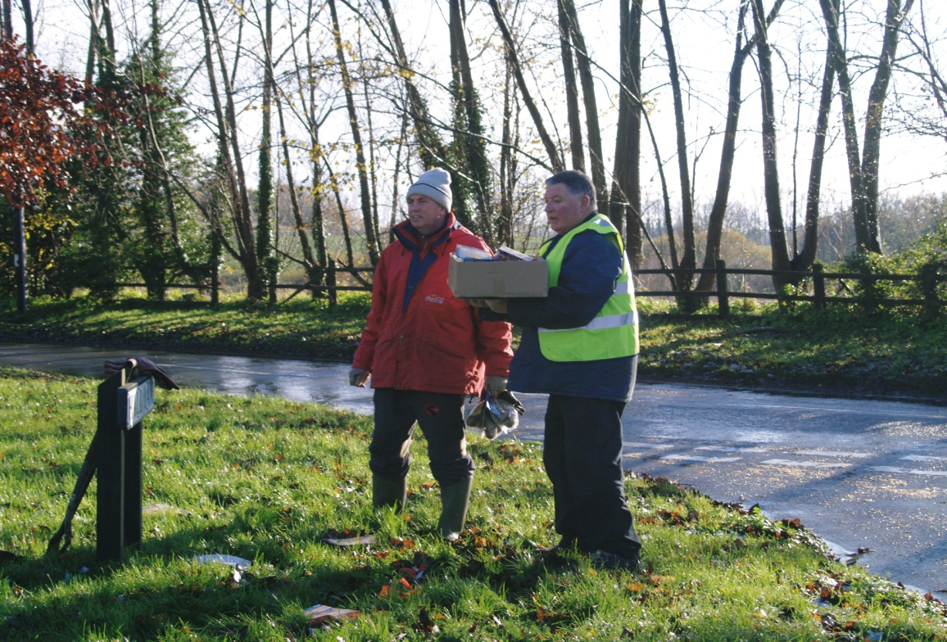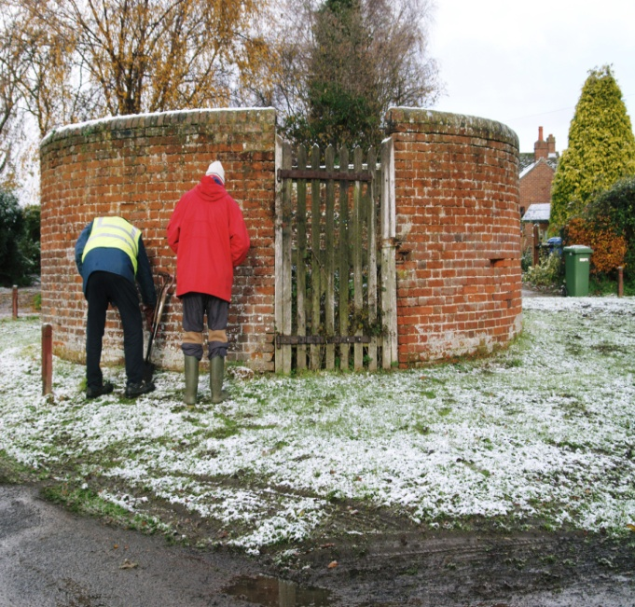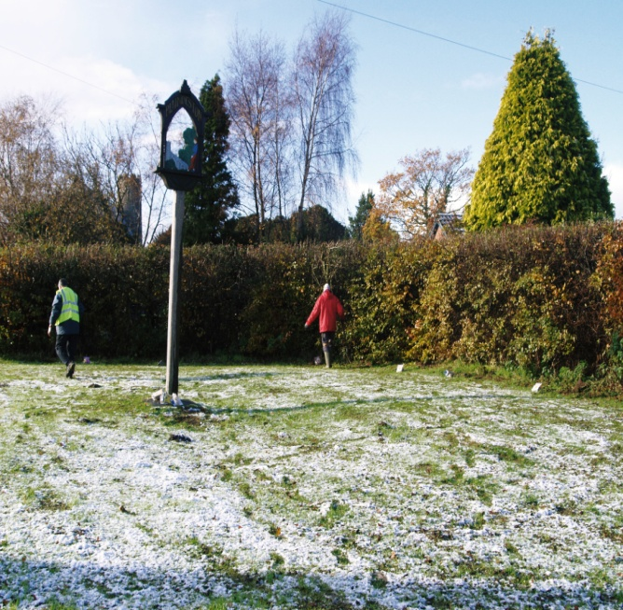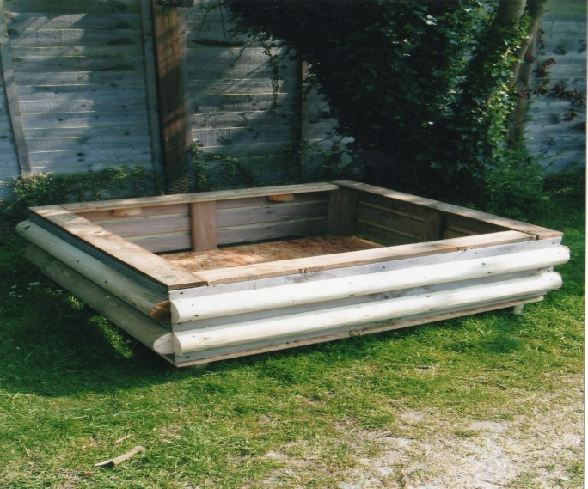
Working at the three sites around the Village on a cold November day and making the Planters (2010)
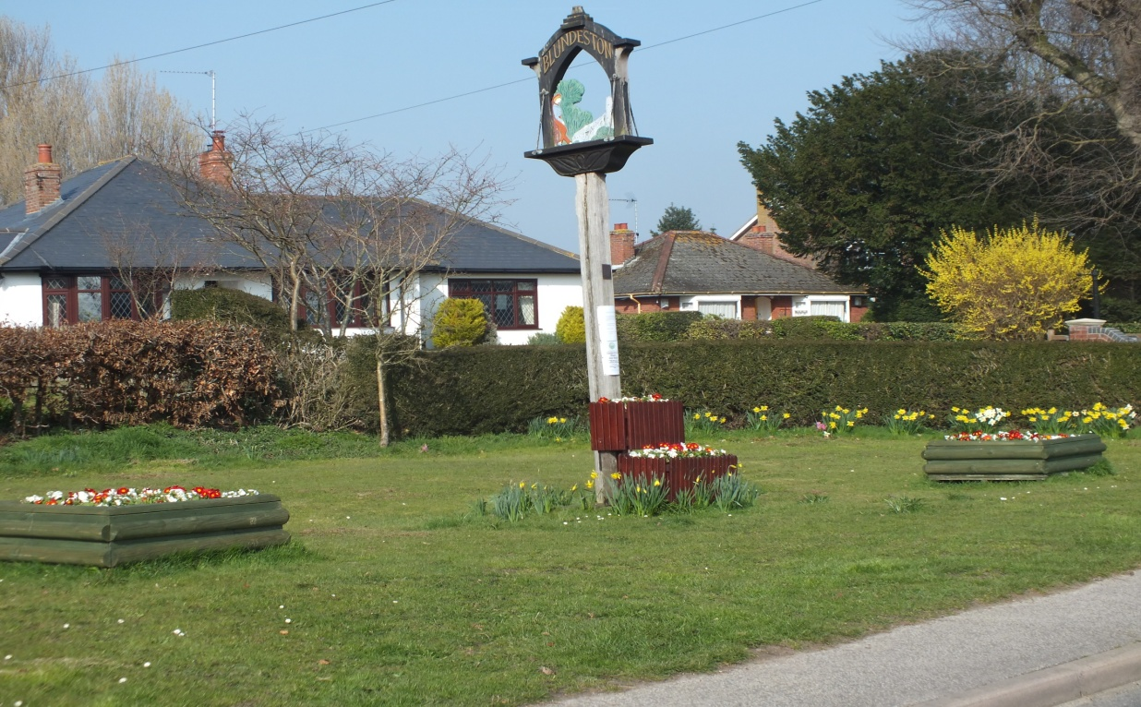

The planters around the Village sign March 2012

For the of 2011/12 winter all the planters were tidied up and re-planted with winter /early spring pansies and polyanthus and bulbs were planted around the Pound, the Village Sign and the hay cart. After a slow start these have all provided refreshing oases of colour during the dull days of winter and have continued to look at their best throughout April and May.

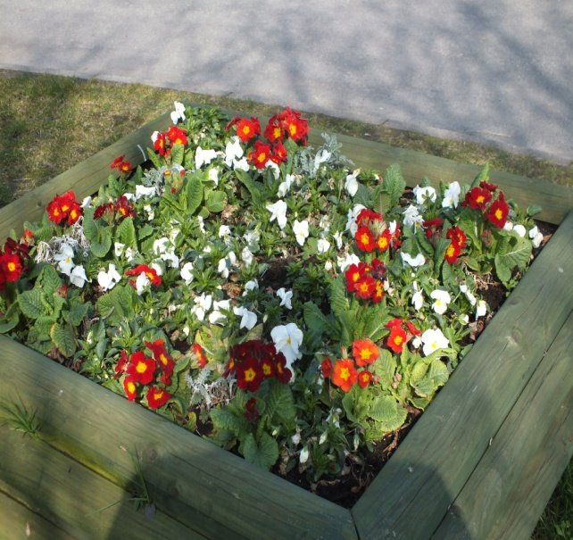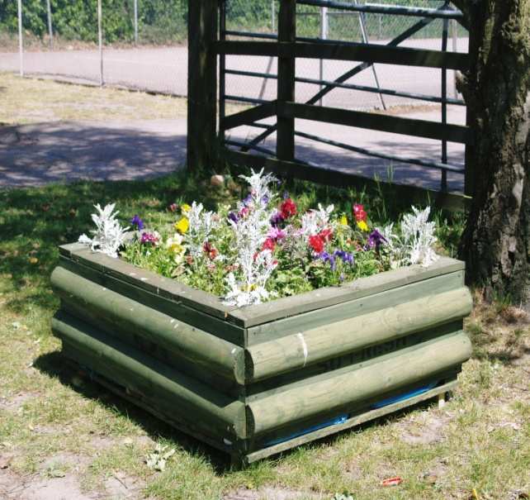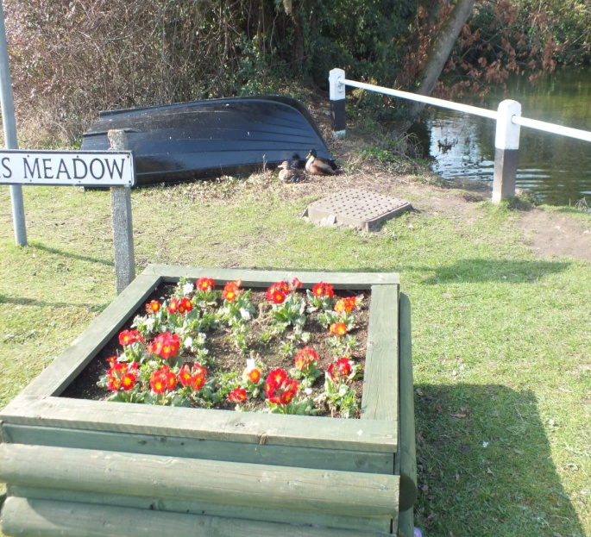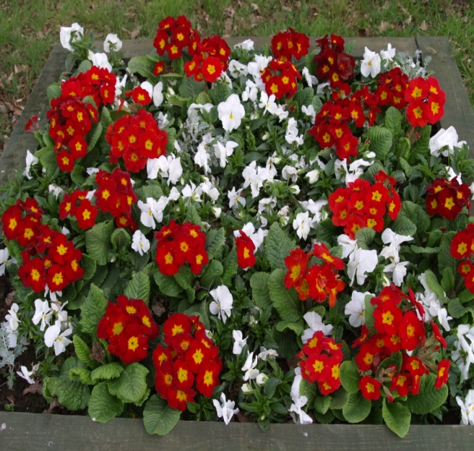

Planters around other parts of the Village (March 2012)
Our logo theme hay cart was especially made for us by the local disability group SOLD and was funded through Suffolk County Council, Locality Budget. It now stands as a major feature on a prominent corner close to the edge of the Village.
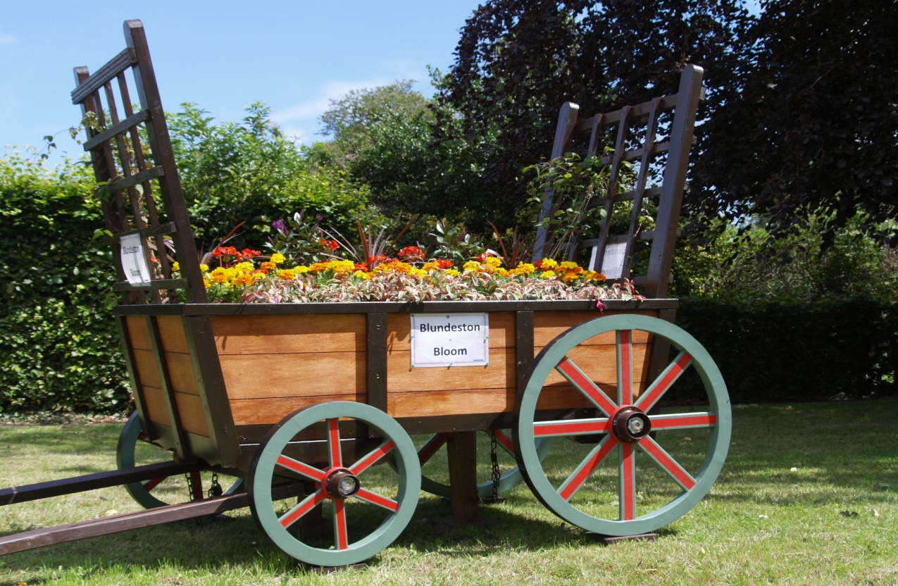

The hay cart planted up for the summer of 2011 (July).

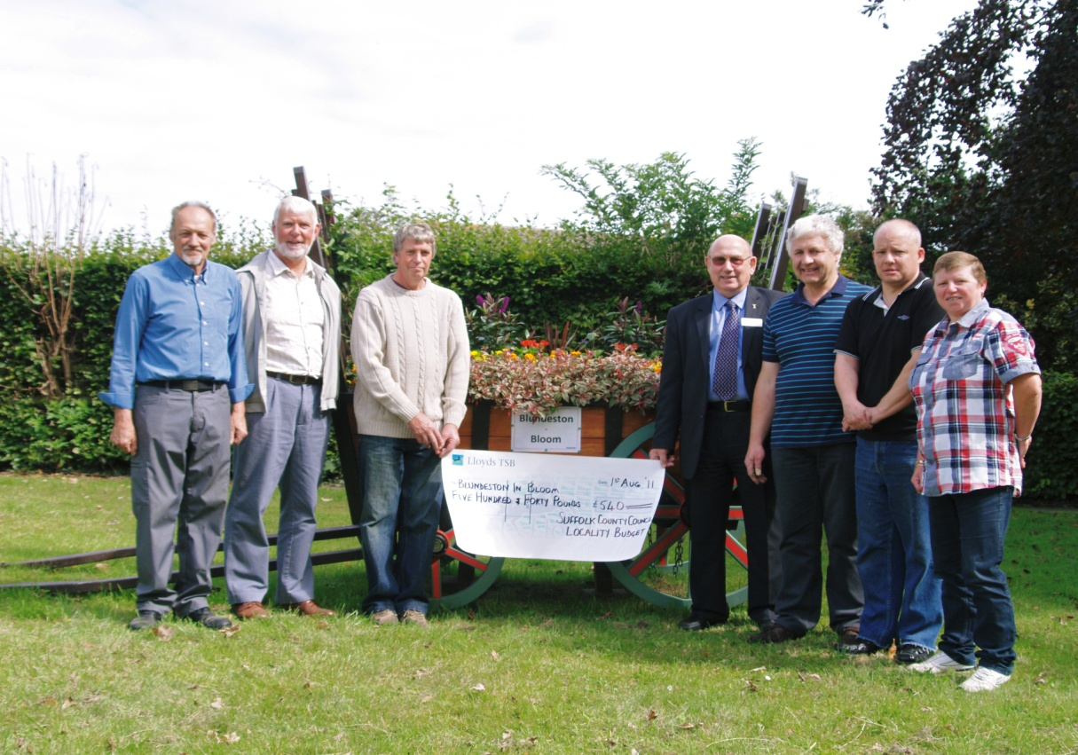

Presentation of the cheque for our theme hay cart with representatives of SOLD and members of the committee and Suffolk County Council (Sept. 2011)

That colourful feature, throughout the summer of 2011, has helped raise the profile of the project and gain us considerable local support and encouragement.

Whilst still enjoying the late spring flowers the team has been hard at work preparing for the summer and what we hope will be a blaze of colour. We agreed that we should target both the Queens Jubilee and the Olympic themes and decided on colours and plant types to order at an early stage. We also decided to use old tractor tyres in strategic places to serve a dual purpose. They provide ideal planting areas and are also excellent obstacles to prevent car parking on grass verges near the Village Hall and Play areas. We have also used five tyres near the Village sign to simulate the olympic rings (without breaching copyright)
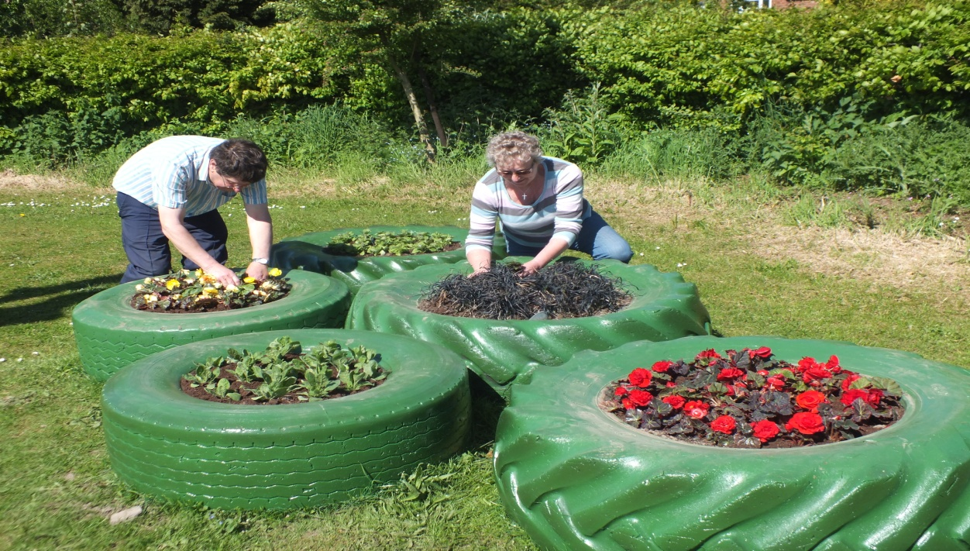

The Olympic rings, being planted out for the summer in May 2012.

We also cleared an area of untidy and overgrown grass verge in Market Lane in order to establish a long term rose bed.

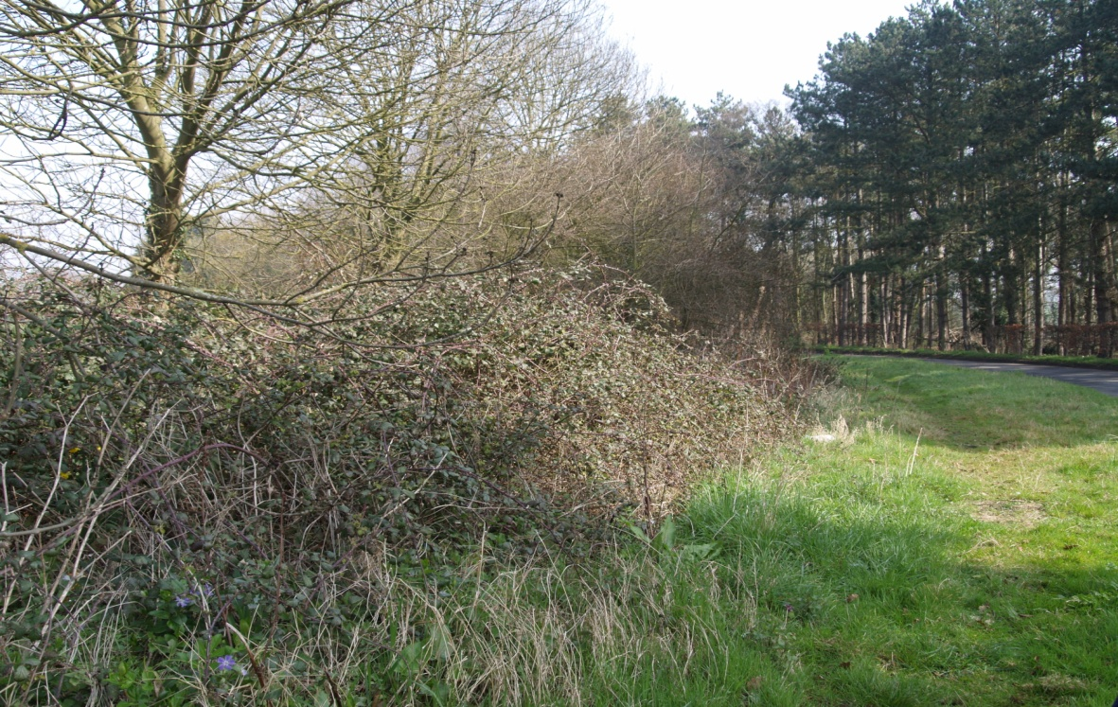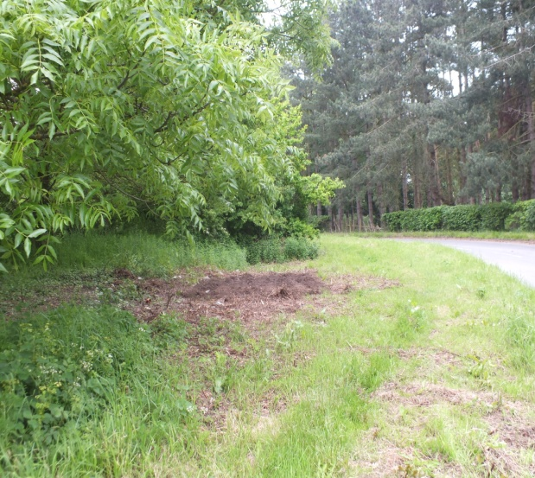

The overgrown verge in Market Lane before (March 2012) and after preparation for the rose bed June 2012)

For this summer’s planting, of the hay cart the planters and the tyres, a variety of garden ready plants were ordered from a reputable national nursery and were all set out by early June.
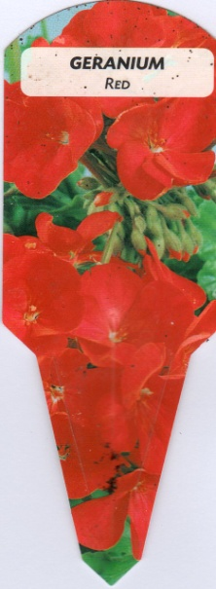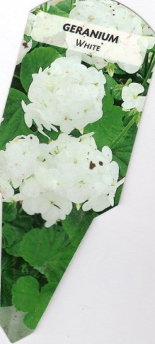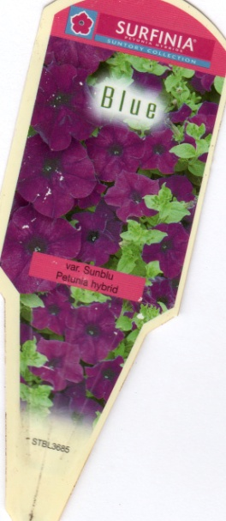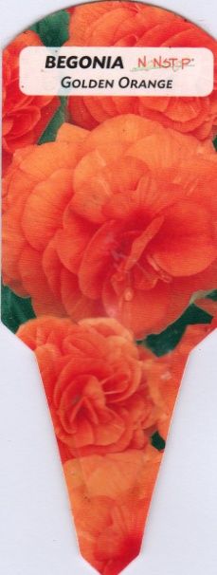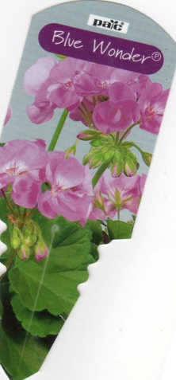

The varieties of garden ready plants purchased for 2012

An old cart was given to us by Somerleyton Post Office. It was crumbling and needed a lot of renovation. We felt that it would form an ideal feature opposite the Plough Inn. This is an old ‘coaching inn’ on the original Gt. Yarmouth to London road and was the starting point for ‘Barkis the Carrier’ in David Copperfield. One of the residents in the adjacent ‘old folk’s bungalows was keen to look after it for us.
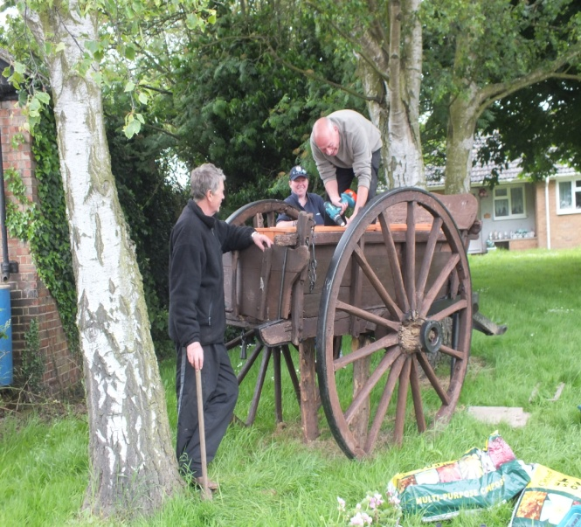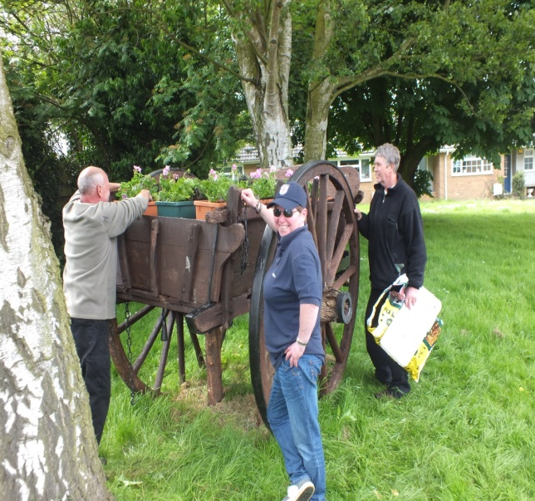

Establishing and planting up the cart by the ‘old folk’s bungalows opposite the Plough (June 2012)

Section 2: Environmental Responsibility
There are some areas of the village which we want to develop as wild areas but before that can happen they all need a considerable amount of development work.

The Millennium Green.
Perhaps our biggest disappointment since we established the Green is the failure to achieve a successful wildflower meadow although Suffolk Wildlife Trust tell us that it is full of a wonderful variety of grasses. The major stumbling block has been that the last agricultural crop on the land was peas leaving behind a soil rich in nitrogen and totally unsuitable for natural wildflowers. The area is slowly improving and last summer the insects in particular the bees loved the proliferation of knapweed. This spring we have received some funding from Suffolk Wildlife Trust and have planted out a variety of over 1000 wildflower plugs which we hope will develop over the years and provide an abundant food source for insects.
Varieties planted: Wild basil; Birds foot trefoil; Clustered bellflower; Cowslip; Field scabius; Foxglove; Great burnet; Lily of the valley; Meadow clary; Meadow cranesbill; Ox-eye daisy; Primrose; Red campion; Red clover; Selfheal; Solomons seal; Tansy; Vipers bugloss; Water avens;
During the winter a Community payback scheme workforce have tidied up the hedge bottoms, ditches and an overgrowth of willow saplings around the edge of the pond, on the Green.
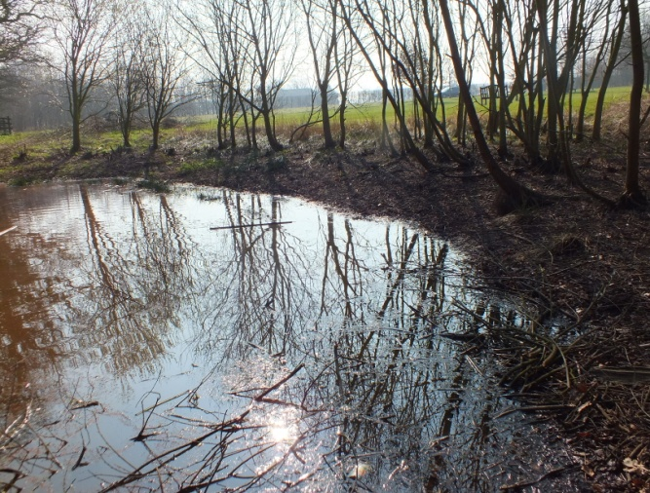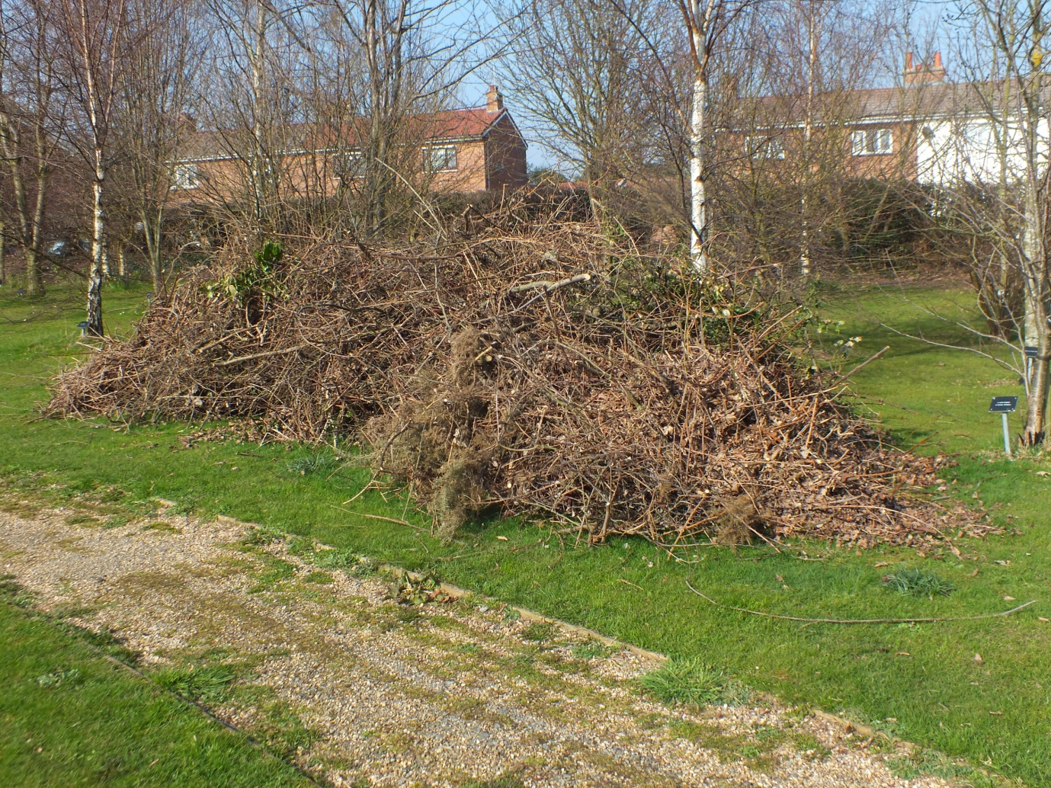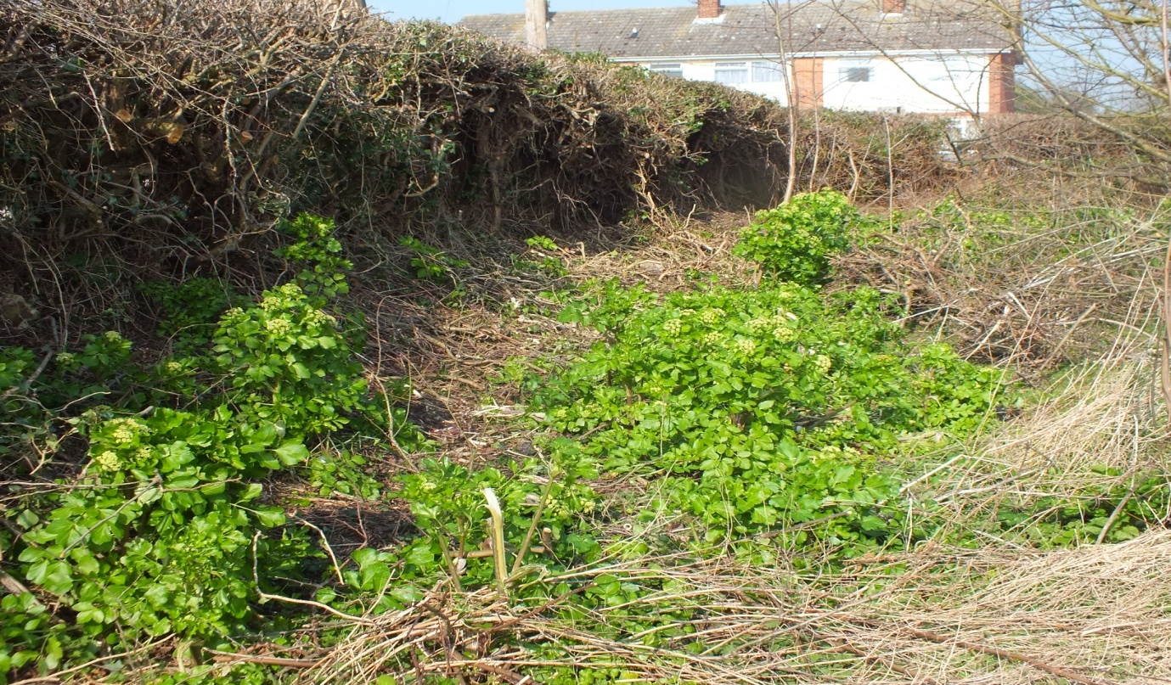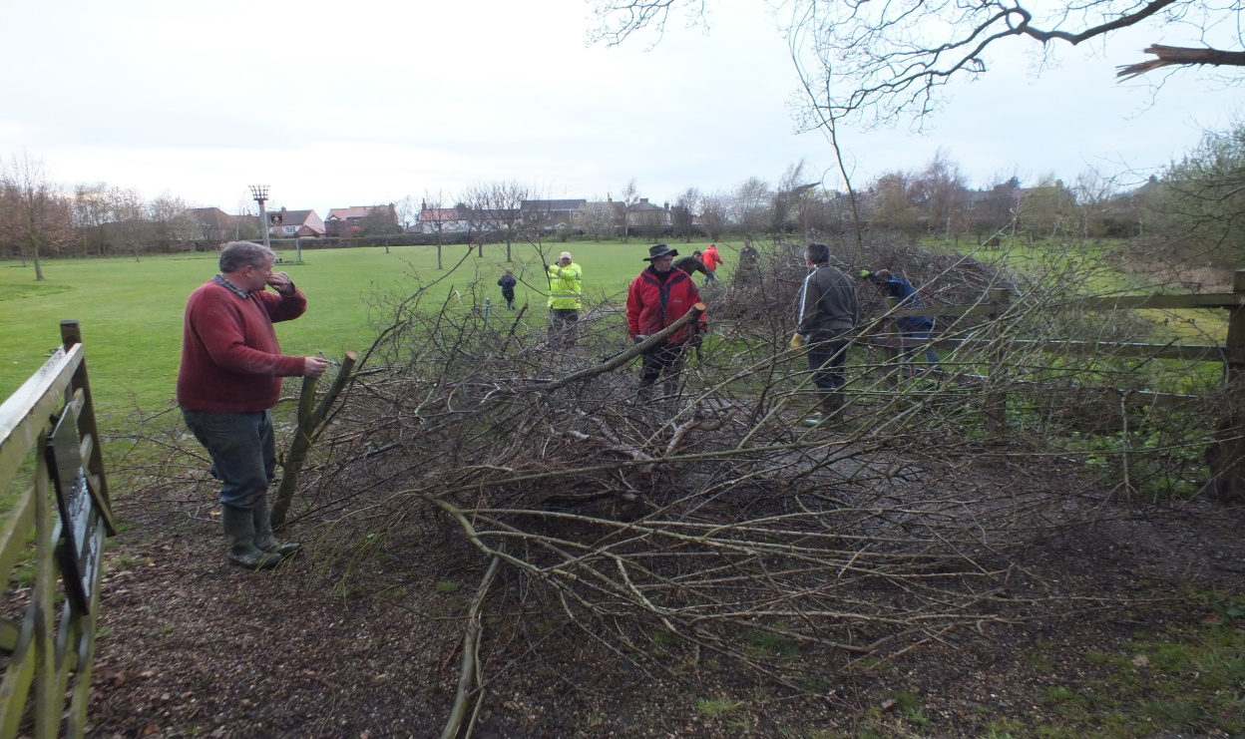
Clearing away all the rubbish from around the hedge bottoms, the ditches and the self sown saplings from around the pond (April 2012).

Barkis Meadow
At the end of Barkis Meadow there is an area originally designated by the developers in 1967 as an open space play area. Over the years this area has been seriuosly neglected. As a part of our project this area has now been tidied up and prepared for managing as a wild area.
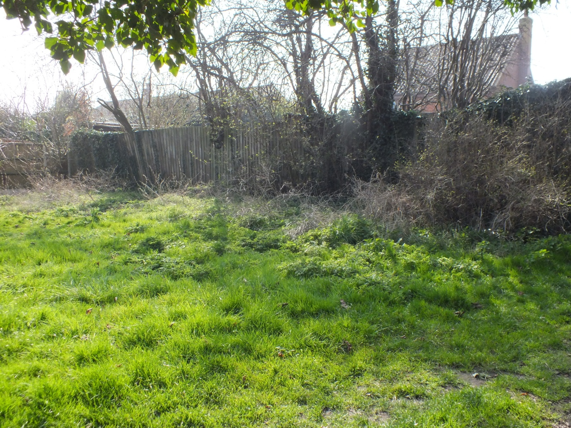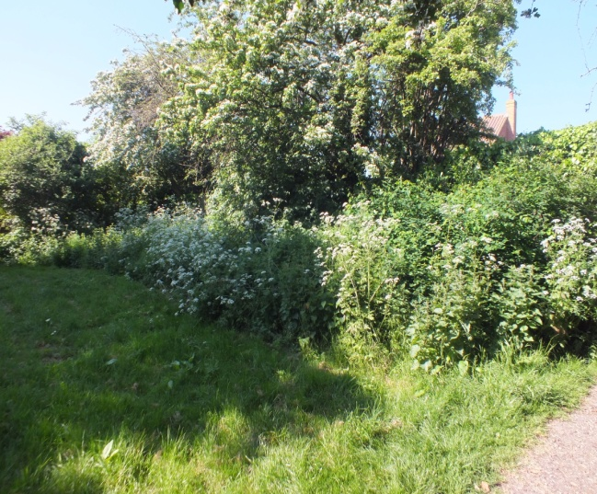

Part of the neglected area in Barkis Meadow (April 2012).

In May 2012 a working party ‘attacked’ the area and prepared it for planting out with insect friendly plants and shrubs to complement areas of nettle and cow parsley which have been left.

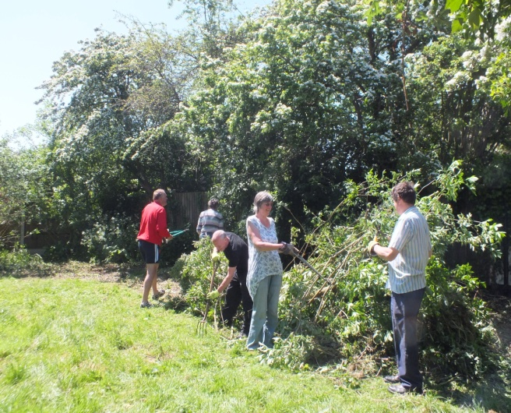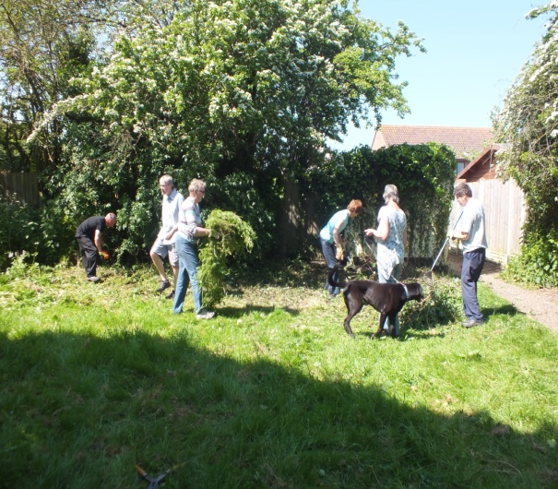

The team tidying up on a warm Spring day (May 2012)

Roadside verges
Wherever possible we have encouraged the local council to retain as much of the wild verges as possible within the constraints of highway safety. One fine example of this is the wide verge area opposite the Church. This area has been left wild for many years and has developed into a colourful and insect friendly environment. So much so that last summer a bee swarm took up residence in the tree oposite the Church!

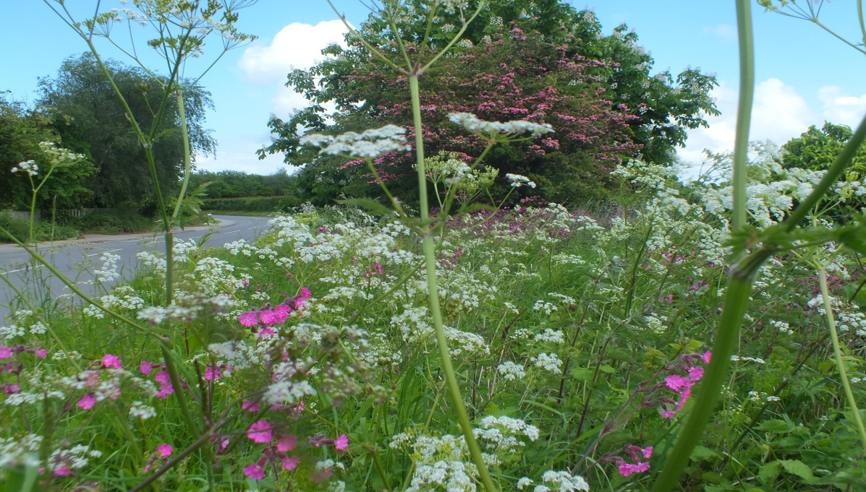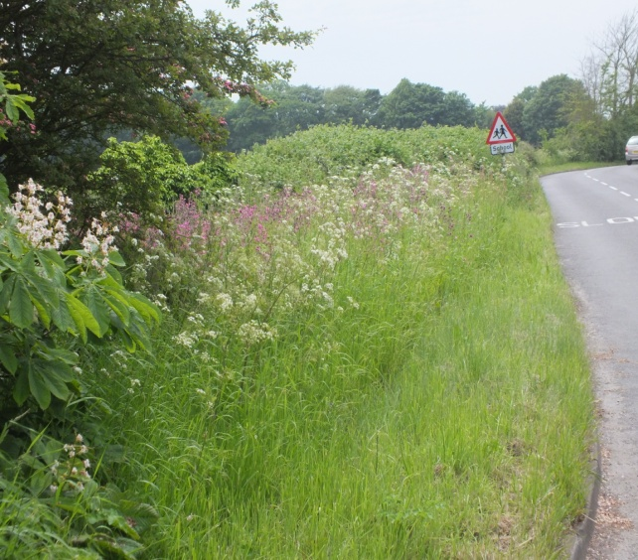

Part of the attractive wild verge in Church Road (June 2012)

Recycling materials
Most of the wood in the square planters has been re-cycled from old onion cases and pallets.
We have improvised with old tractor tyres for planters in some parts of the village where they also serve to stop parking on the grass verges.
Most of the ‘filler’ soil in the bases of the planters has been from local building projects and sites.
The old cart opposite the Plough was rescued from the bonfire and given to us by Somerleyton Post Office.
We have also made use of a derelict boat, half as a planter on Lowestoft Road the other half as a seat by the pond in Barkis Meadow

Section 3: Community Involvement

St Mary’s Church
A small dedicated band of workers maintain our large churchyard in excellent condition throughout the year. They gather weekly to tidy the grass areas and trim the trees. During the winter of 2011/12 they planted over 1000 daffodil bulbs throughout the large churchyard.
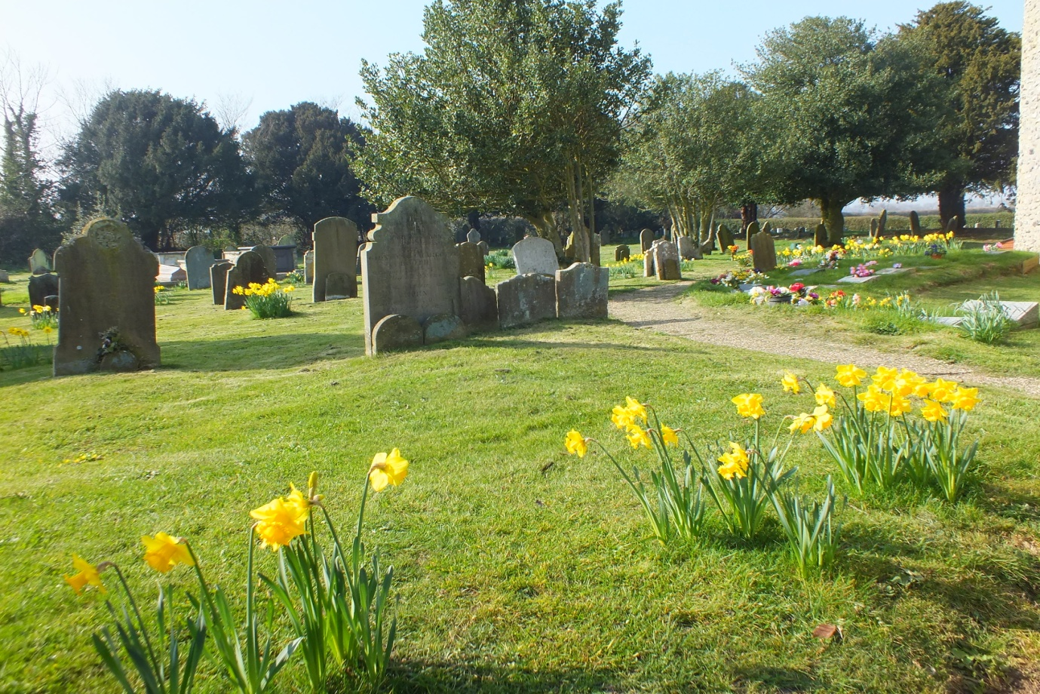

St Mary’s Churchyard in the spring 2012 (March)

The Millennium Green
The original transformation of an open agricultural field into what we have now, with copses and western hedge planted as twigs and the wildflower meadow, was all the work of local volunteers. Whenever there is a job to be done on or around the Green there has never been a shortage of people willing to do it. This is a tribute to the pride villagers have in what we consider to be the ‘jewel in our crown’.

So recently we needed the help of a local farmer and another working party to clear away all the rubbish resulting from the Millennium Green tidy up carried out by the Community Payback scheme. The call went out and many hands indeed made light of the work. This left the whole area looking in fine condition ready for the Diamond Jubilee celebrations on The Green.

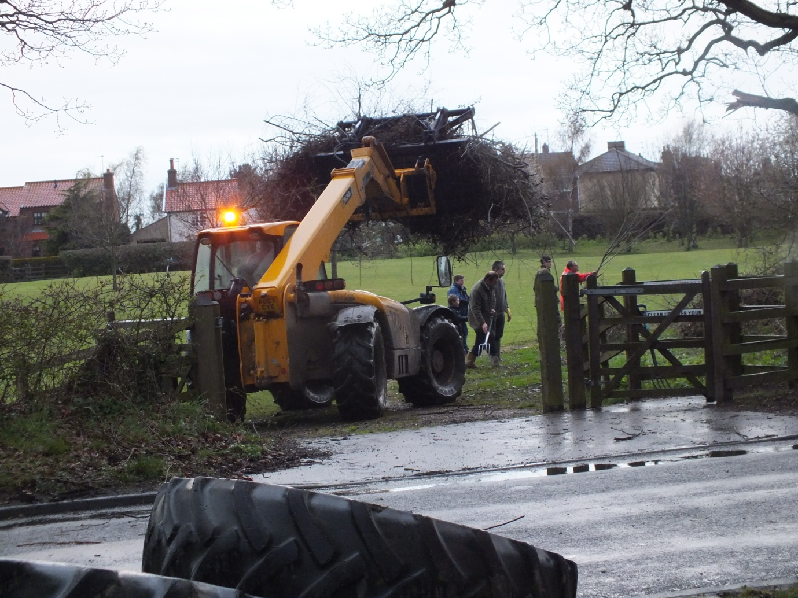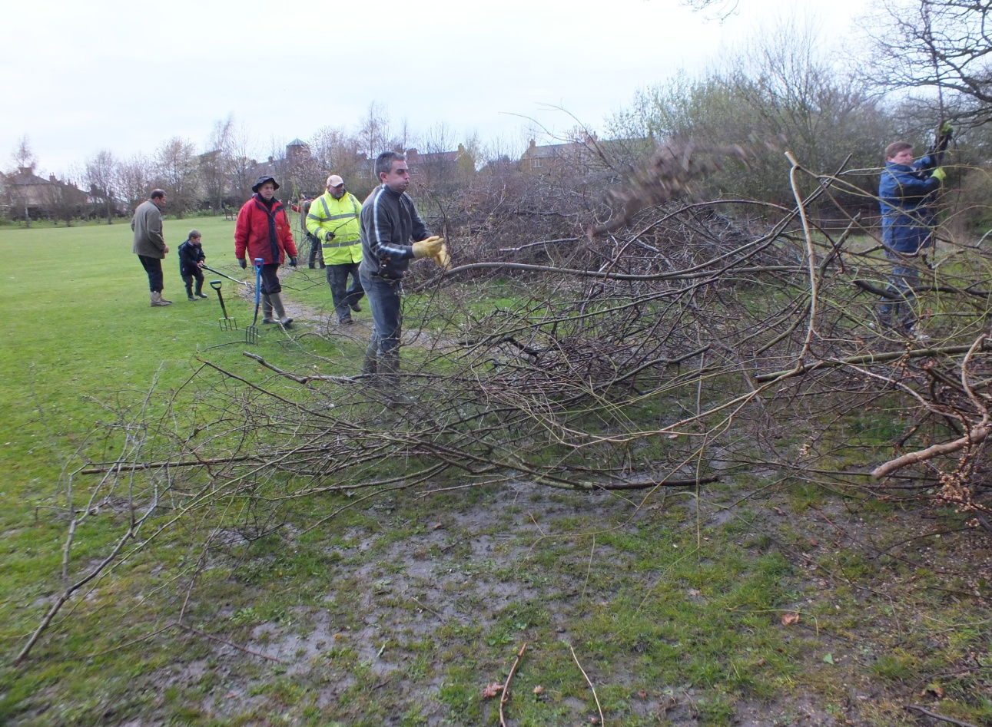

Manual and mechanical help to clear away the rubbish (April 2012)

The Bowls Club
There has been a Bowling Green in Blundeston on its present site - adjacent to the Plough Inn - since 1921. Previously the game was played at the large house, Blundeston Hall, where Blundeston Prison now stands.
In recent years it became apparent that the antiquated facilities at the venue, (old shed, no toilet!) adjacent to the Plough Inn, were no longer acceptable and in 2009, with the help of various grants, a new club house was put on site with all modern facilities including flush toilets! Most of the work was carried by the members. As a part of the refurbishment the area in front of the new clubhouse was landscaped to provide a very pleasant backdrop to the playing area. The members are keen to have the Green associated with the Blundeston in Bloom project and and hope that the judges have time to walk through the Green.
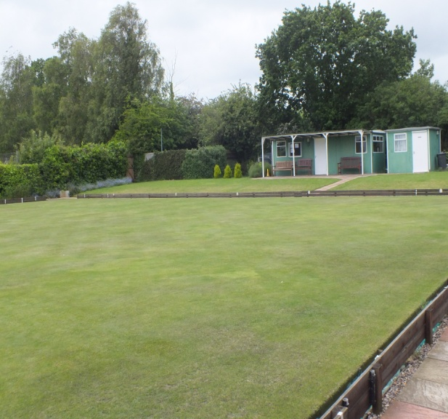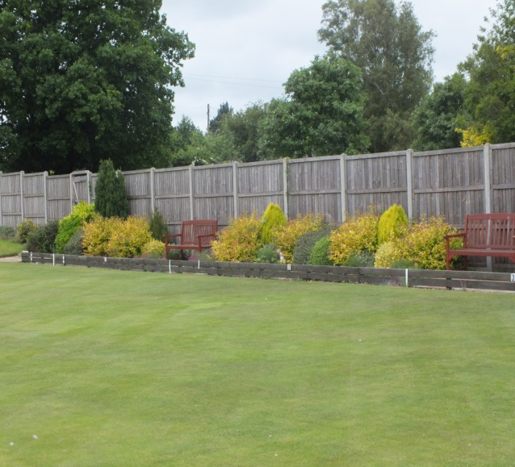

Blundeston Bowls Club (June 2012)

Blundeston School
The school were keen to become involved and agreed to be responsible for some appropriate murals in the village. They were keen to make an impression on the unsightly hoardings bordering the old garage site, scheduled for a housing development. It was too dangerous to work on site so they have made murals on hardboard sheets back at school. They are keen to keep these a secret from all of us so there artwork will come as a surprise to us all on judging day.
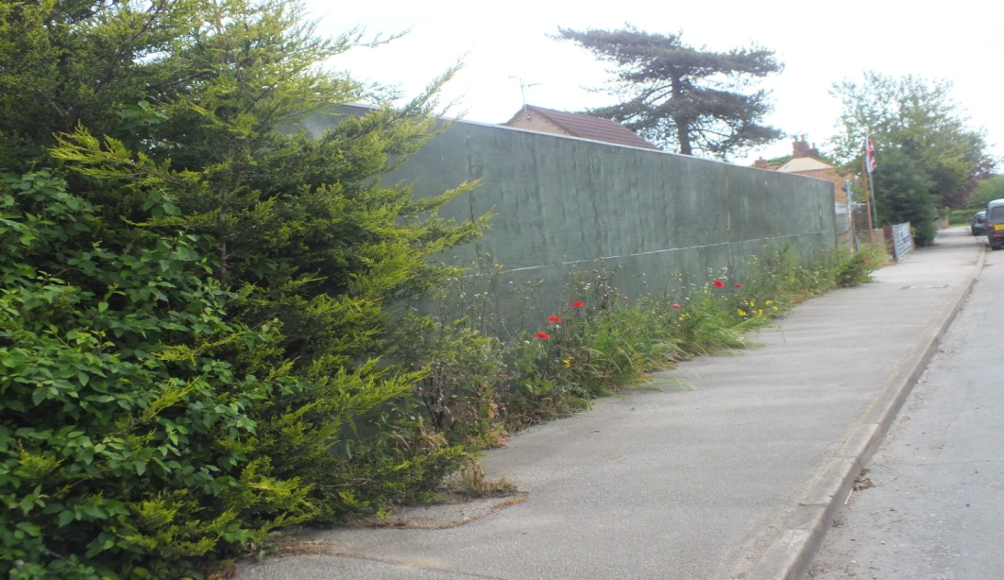

What surprise awaits us here on 6 July! (June 2012

The Plough Inn
The historic Plough Public House was the starting place for ‘Barkis the Carrier’ in Charles Dickens novel ‘David Copperfield’. The pub is very much a part of the community and regularly hosts Community events including most recently a band and barbeque for evening of the Queen’s Diamond JubileeThe forecourt is always well maintained and in the past has been awash with colour.

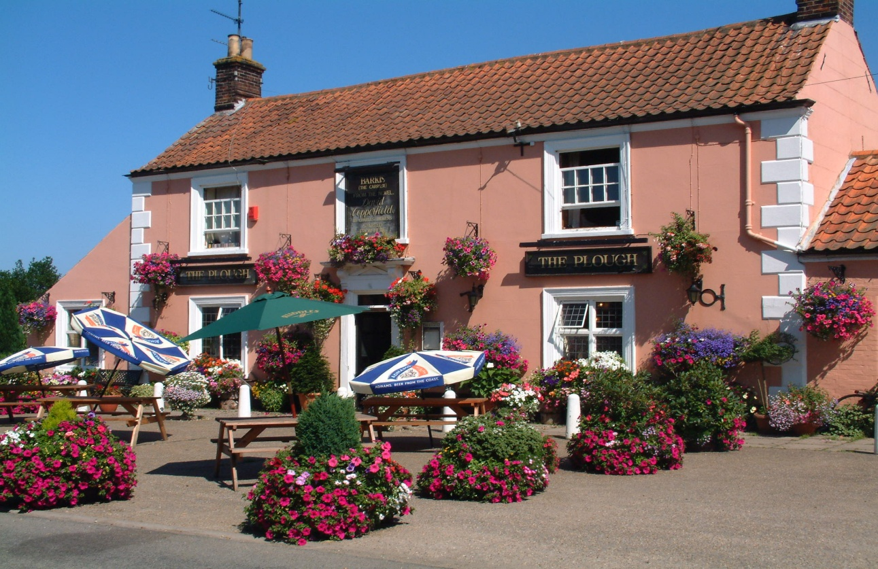

The forecourt of the Plough Inn in the summer of 2009 (July).

Fundraising
Apart from some generous donations we have been heavily dependent on various fundraising events to finance our efforts to date.
The most successful financially was the ‘Open Gardens’ event which raised a total of £986. Held on a fine Saturday in July people from far and wide came and enjoyed the twelve very different gardens. Most of the gardens had extra attractions including tea and cakes, books and a barbeque. This will be repeated on Saturday 7th and Sunday 8th of July 2012.
During the winter we hosted the Eastern Arts live theatre group in the Village Hall and raised £145. We have also had a chocolate demonstration by one of our group, and a quiz night raising £244 in total.
In 2011 the local Woman’s Institute kindly organised a Coffee morning and Spring Fayre and raised over £340 for us.
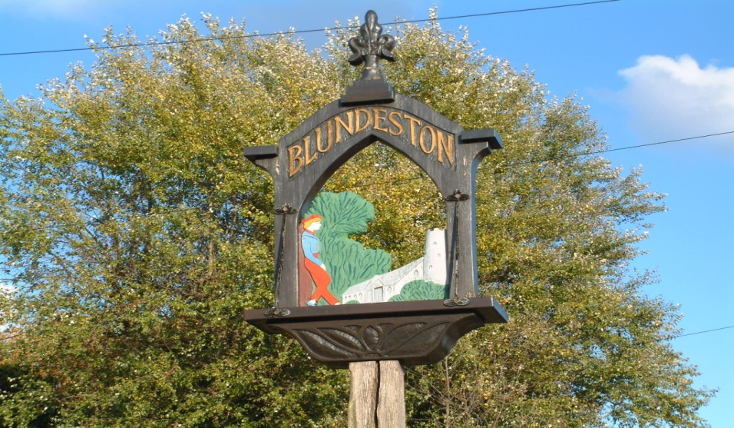

Blundeston in Bloom 2012

